CYLINDERS
Pearson Edexcel - Tuesday 11 June 2019 - Paper 3 (Calculator) Higher Tier
1.
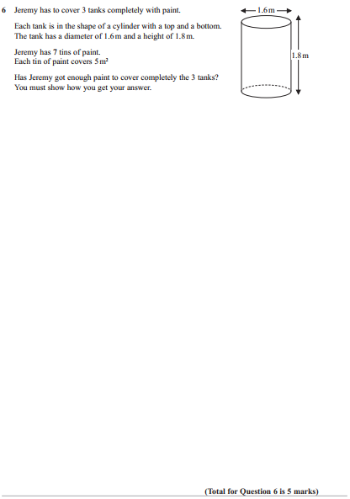
OCR GSCE – Monday 9 November 2020 – Paper 6 (Calculator) Higher Tier
2.
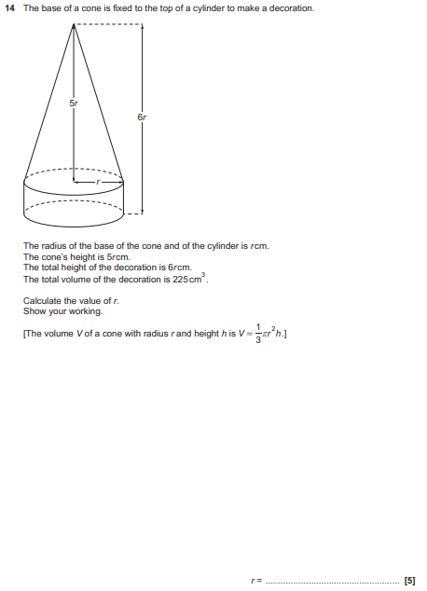

OCR GSCE – Tuesday 6 November 2018 – Paper 4 (Calculator) Higher Tier
3.
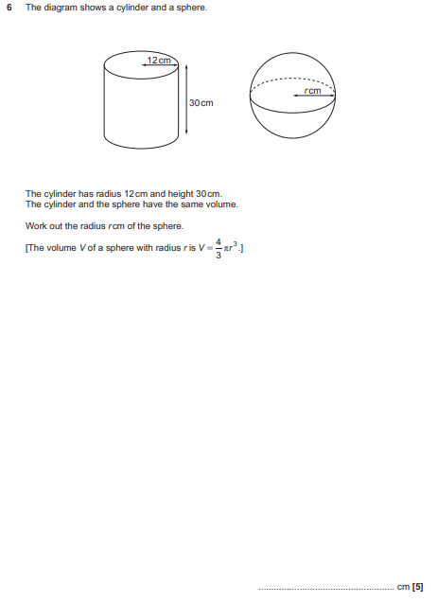

OCR GSCE – Tuesday 6 November 2018 – Paper 4 (Calculator) Higher Tier
4.
